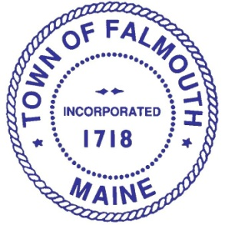
FEIC
Falmouth Economic Improvement Committee +
William Lunt III, Chair
Janice DeLima, Vice Chair
Dimitri Balatsos
Pamela DiPietro Hale
Sandra Lipsey
Anne Theriault
Lucas Walker
Chris Wasileski

Council Liaison
Karen Farber

Staff
Nathan Poore
Theo Holtwijk
Falmouth Economic Improvement Committee +

MEETING
Wednesday, September 16, 2015
Town Hall, Large Conference Room, 2nd Floor
3:30 - 5:00 PM
AGENDA
- Review of Draft Minutes of August 19, 2015 meeting

- Update on FEIC Charge and Membership Amendment

- Review draft schedule for 2015-16 Work Plan

- Discuss

- Other Business

- Next Meeting

For more information regarding this meeting, please contact
Theo Holtwijk, Director of Long-Range Planning, 699-5340, tholtwijk@falmouthme.org

