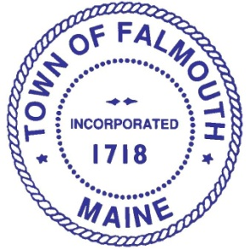

Appointment Committee Members Combined
Councilor Asherman
Councilor
Ferrante-Chair

Councilor
Kuhn

Appointment Committee
(Town Council Sub-committee)

MEETING AGENDA
Monday, January 7, 2019
Town Hall, Large Conference Room

4:30 PM
- Approval of 2018 Meeting Minutes

- Discussion on Wellness

MaryBeth Bachman, Robyn Haley and Sarah Maloney were invited to share their knowledge and ideas on the topic of Wellness in Falmouth

- Interviews

- Marty Bruno Harbor/Waterfront
- John Lane Multi Boards
- Liz Wyman LPAC
- Lindsey Dumas Library
- Randall Cooper BZA
- Valentine Sheldon Multi Boards

- Schedule next Meeting

For more information regarding this meeting
Please contact the Clerks Department
781-5253 ext. 5305

