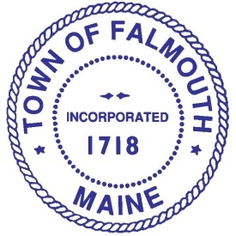

Committee Members

Andrea Ferrante
Chair

Joseph McDonnell
Vice Chair

Sarah Boudreau

Rebecca Grover

Lori Legere

Charlie McBrady
Council Liaison

Steve Melchiskey

Eydie Pryzant

vacancy
FEIC Liaison

Jim Thibodeau
LPAC Liaison

Ad Hoc Route 100 Committee

Meeting
Wednesday, September 16, 2015
6:00-7:30 PM
Town Hall, 2nd floor conference room

Agenda

- Review Draft Minutes of August 26, 2015 meeting

- Review updated meeting schedule

- FST progress update

- Discuss 9/30 public forum

- Next Steps

- Other Business

- Next Meeting

Please contact Theo Holtwijk, Director of Long-Range Planning at 699-5340 or tholtwijk@falmouthme.org if you would like more information. Thank you.

