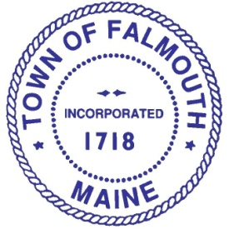

Long Range Planning Advisory Committee (LPAC)

LPAC Members

Sam Rudman
Chair

Sandra Lipsey
Vice Chair

Bill Benzing

Paul Bergkamp

Kurt Klebe

Erin Mancini

Jim Thibodeau

Karen Farber
Council Liaison

Meeting

Thursday, September 17, 2015
6:00 PM
Town Hall, 2nd floor Conference Room

Agenda

- Review of Draft Minutes August 13, 2015 Meeting

- Review of Resource Conservation Zoning Overlay District

- Update on West Falmouth Sewer Master Plan

- Other Business

- Next Meeting

Please contact Theo Holtwijk, Director of Long-Range Planning at 699-5340 or tholtwijk@falmouthme.org if you would like more information or would like to be added to the committee’s distribution list. Thank you.

